

soen6222 self evaluation

St10272710



meshaya munnhar

## Self-evaluation

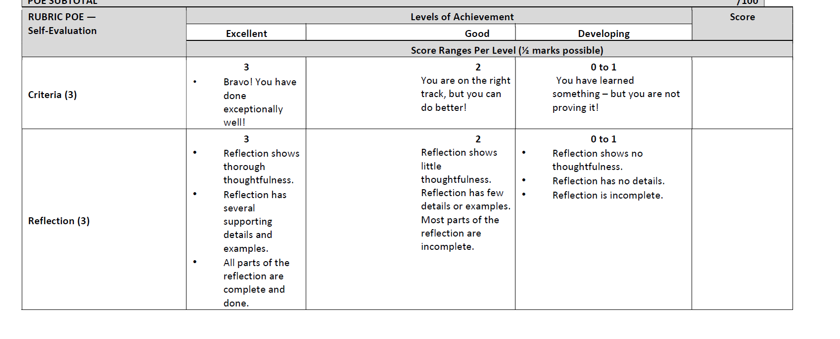

Criteria – 3

Reflection – 3

Demonstration of Learning – 4

## Self-reflection of SOEN6222 Module

I found the software engineering module to be highly informative and interesting. The course covered a broad spectrum of topics, each offering unique insights into the field of software development. While I enjoyed all the learning units, I found the unit on architecture, design, and implementation particularly fascinating. This section provided a deeper understanding of how to structure and design software systems effectively, ensuring they are scalable, maintainable, and meet user requirements. The practical application of these principles through case studies and projects helped solidify my understanding.

Additionally, this unit emphasized the importance of collaboration and communication within development teams, which I found both challenging and rewarding. Learning about design patterns, system modeling, and implementation strategies helped me see the real-world impact of thoughtful design on project outcomes. Reflecting on my progress, I realized how much my problem-solving and critical thinking skills improved throughout the module. This learning unit has also inspired me to explore advanced topics in software architecture and design, as I recognize their relevance in building high-quality software solutions. Overall, this module enhanced my technical skills and broadened my perspective on the complexities and responsibilities of a software engineer.